|  |  |  |  |  |  |
| --- | --- | --- | --- | --- | --- |
| **1 min** | **Shot** | **Cavity** | **1 max** | **Shot** | **Cavity** |
| 10.037 | 1 | 1 | 10.106 | 1 | 1 |
| 10.011 | 1 | 2 | 10.102 | 1 | 2 |
| 10.047 | 1 | 3 | 10.085 | 1 | 3 |

|  |  |  |
| --- | --- | --- |
| **Apl.** | **K2002-Merkmal** | **K2003-Description** |
|  | 1 min | Durchmesser |
|  | 1 max | Durchmesser |
|  | 1 Gauss | Durchmesser |
|  | DIN Run_1 | Rundheit |
| Etc. | Etc… | Etc… |
|  | DIN Run_14.2 | Rundheit |

1. Load/modify/export the DFQ file. (Example added)
   1. **File path to be defined over TKinter,**
   2. Check if the Shots are available, if not -> Input Box (number of shots: e.g: 7), modify DFQ file respectively.
   3. Check if the Cavities are available, if not -> Input Box (number of cavities: e.g: 8), modify DFQ file respectively.

**Loading animation over python, or over simple GUI MsgBox.**

1. Create the PDF Report (as of the wished example) containing at least following data:
   1. DataTable Name (Merkmal) - (has respective K-field from DFQ)
      1.  
   2. USL/LSL and Nominal

 (has respective K-field from DFQ)  
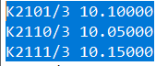

Nominal = K2101  
USL (Upper Spec. Lim.)= K2111  
LSL (Lower Spec. Lim.) = K2110

* 1. Columns: Shot Nr. (K0006 field from DFQ),
     1. MIN/MAX/RANGE per each column (absolut MIN per Column (bold)/absolut max per Column (bold), max. Range per Column (bold)

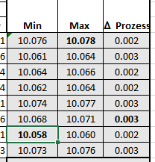

* 1. Rows: Cavity Nr. (K0007 field from DFQ)
     1. MIN/MAX/RANGE per each row (absolut MIN per row (bold)/absolut max perrow (bold), max. Range per row (bold)
  2. 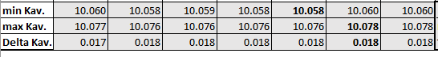

Small table as follows:

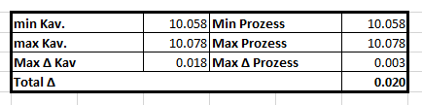

Graphic

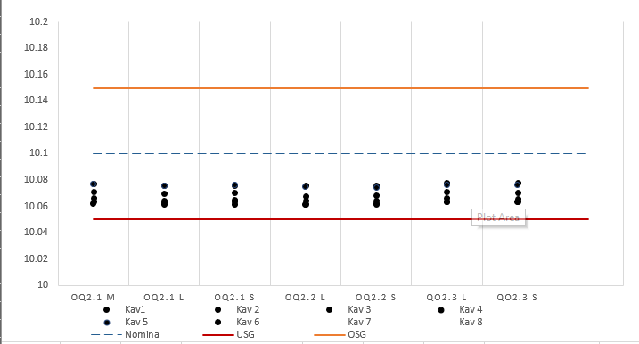

*\*1 Merkmal (K2002) per Side!*

**MsgBox (Done), open report? YES/NO -> if yes, open PDF over default PDF reader, of no cancel as Boolean.**